The Length of Rental screen is intended to maximize yield by denying reservation requests for shorter rentals in favor of longer rentals when fleet is in high demand.

Length of Rental screen : /FOR AVLBLORU <enter>

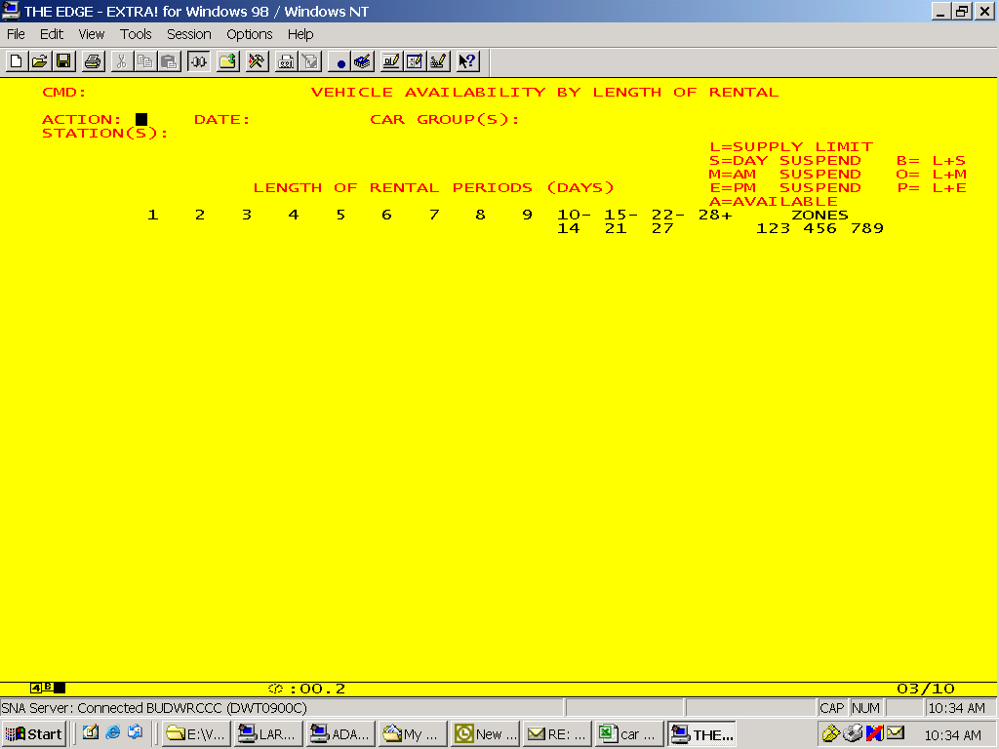

- ACTION : valid actions are DIS and UPD
DIS is used to Display length of rental status for a given month.
DIS must preceed a UPD transaction.
UPD is used to modify previously loaded LOR data.
- DATE : valid format is MMMYYYY
- CAR GROUP(S) : For US, Canada, Puerto Rico, Australia, New Zealand and Asia/Pacific only: X, A, Z, B, C, D, E, S, P, G, H, L, K, W, V, F
- STATION(S) : any valid four digit Budget Wizard rental, district or fleet owner station. Up to 20 stations may be updated in one transaction.
- LENGTH OF RENTAL PERIODS (DAYS)
  - Columns numbered 1, 2, 3, 4, 5, 6, 7, 8, 9, 10-14, 15-21, 22-27, 28+ are the LOR buckets. The buckets for the 10-14, 15-21, 22-27 and 28+ lengths of rental are indivisible. For example, suspending the 10-14 LOR bucket on a particular date will deny any rental requests starting that date for 10, 11, 12, 13 or 14 days.
  - Valid entries for these columns are S = Suspend and A = Available. The Suspend and Available statuses entered on this screen will be applied to stn/date/car groups that have been set to Available via STDBAVL. An entry on STDBAVL will override any previous entries made on AVLBLORU.
    - S = Suspends car availability for rentals of this length
    - A = Available for rentals of this length

  - All other statuses listed on the screen (L, M, E, B, O, P) are for display only and should not be used in the LOR status fields.

